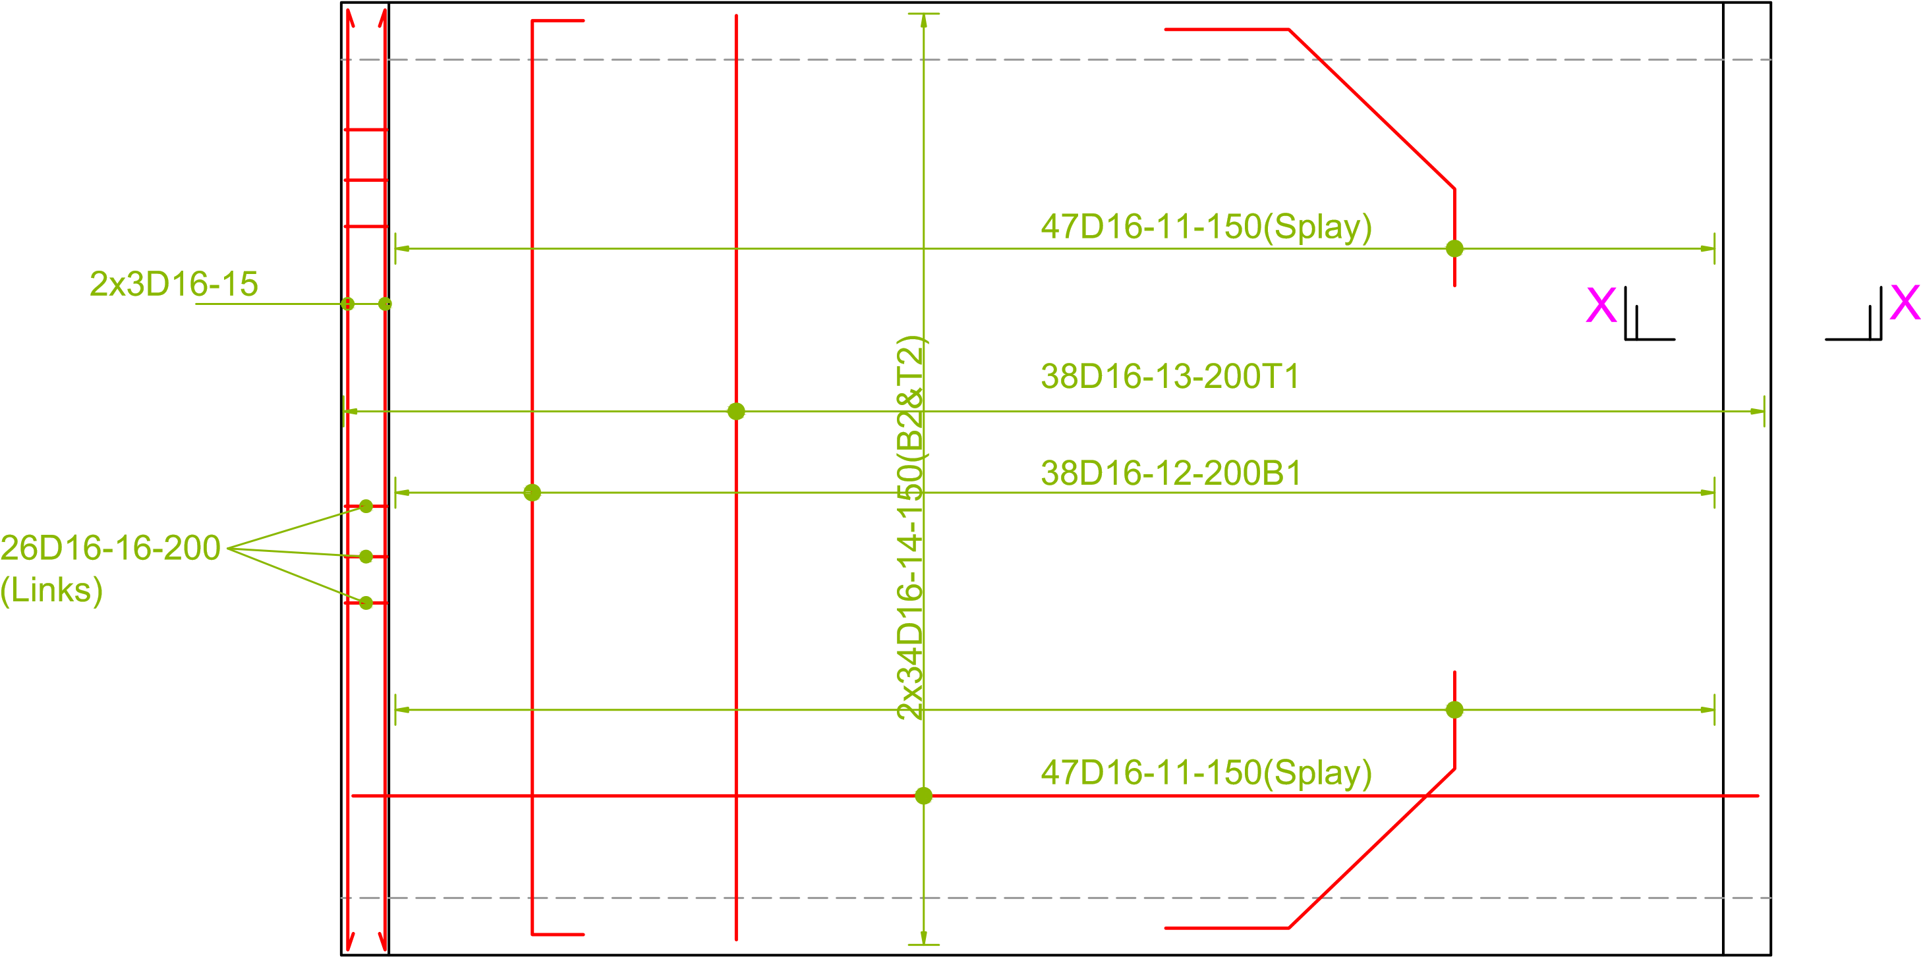
TOP SLAB
DESIGNED BY: D.S TELIENY P.ENG.TECHN | CLIENT:  KENYA CEREALS ENHANCEMENT  PROGRAMME-CLIMATE RESILIENT LIVELIHOODS WINDOW (KCEP-CRAL)  PROJECT:  PROPOSED CONSTRUCTION OF A SMALL SPAN BOX  CULVERT FOR ROAD SPOT IMPROVEMENT WORKS  LEADING TO MWIRERI/WITHIMA STORE IN MOLO SUB COUNTY, ELBURGON WARD | REVISIONS |  | PROJECT: PROPOSED BARAKA BOX CULVERT
 |  | DATE | DESCRIPTION
DRAWN BY: D.S TELIENY P.ENG. TECHN
 |  |  |  | TITLE: PLAN, ELEVATIONS & SECTIONS
CHECKED BY:
APPROVED BY: |  |  |  |  | DATE: SEPTEMBER, 2020 | DWG.NO.:  KCEP-CRAL/003/2020
 |  |  |  |  | SCALE: NTS | SHEET NO.: 003

